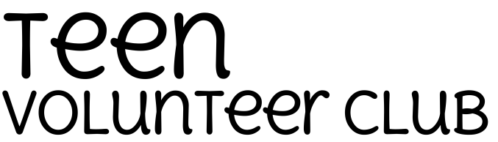

PERSONAL INFORMATION
FIRST NAME LAST NAME APPLICATION DATE
ADDRESS CITY STATE ZIP CODE
PHONE EMAIL ADDRESS DATE OF BIRTH (mm/dd/yyyy)

EMERGENCY CONTACT
NAME PHONE RELATIONSHIP

EDUCATION
CHECK HIGHEST GRADE COMPLETED NAME OF CURRENT SCHOOL
7 8 9 10 11 12

EMPLOYMENT
MOST RECENT EMPLOYER ADDRESS PHONE

JOB TITLE EMPLOYMENT STATUS EMPLOYMENT DATES
Full Time Part Time

AVAILABILITY
DAY | Sunday | Monday | Tuesday | Wednesday | Thursday | Friday | Saturday
TIME

VOLUNTEER INTERESTS
WHY WOULD YOU LIKE TO JOIN THE TEEN VOLUNTEER CLUB?

PLEASE READ CAREFULLY BEFORE SIGNING
I certify all information provided on this application is true and complete. I understand that falsification of this application may result in disqualification from volunteer opportunities. I authorize the Milwaukee Public Library to make any inquiries about and receive any information about my suitability for volunteer work, including conducting a criminal background check. I give permission to persons contacted to provide such information. I forever waive, release, and covenant not to sue any person or organization for any result of providing, obtaining, or acting upon such information. I understand that such information is sought with confidentiality, and I will not request copies of such information. A copy of this authorization shall be as effective as the original. I further understand that there is no compensation for volunteer services, no will subsidies be paid for transportation, parking, meals, etc. nor will volunteer service lead to employment with the Milwaukee Public Library.
SIGNATURE DATE

PARENT or GUARDIAN CONSENT (only for volunteers under age 18)
I give permission for the above applicant to volunteer at the Milwaukee Public Library. I fully understand the nature of the activity described above and the risk of injury or loss of property associated with that activity. By signing, I release the Milwaukee Public Library and its employees from any claims made by the minor should injury or loss of property occurs as a result of their participation.
NAME PHONE RELATIONSHIP

I acknowledge having read this Consent and Release information and fully understand its contents and the consequences of signing this form.
SIGNATURE DATE

INSTRUCTIONS
Please return completed and signed application to:

By Mail: Volunteer Coordinator, Milwaukee Public Library, 814 W. Wisconsin Ave, Milwaukee, WI 53233
By Fax: (414) 286-3831
By Email: MPLvolunteer@milwaukee.gov (signed applications should be in PDF format)

